3.1

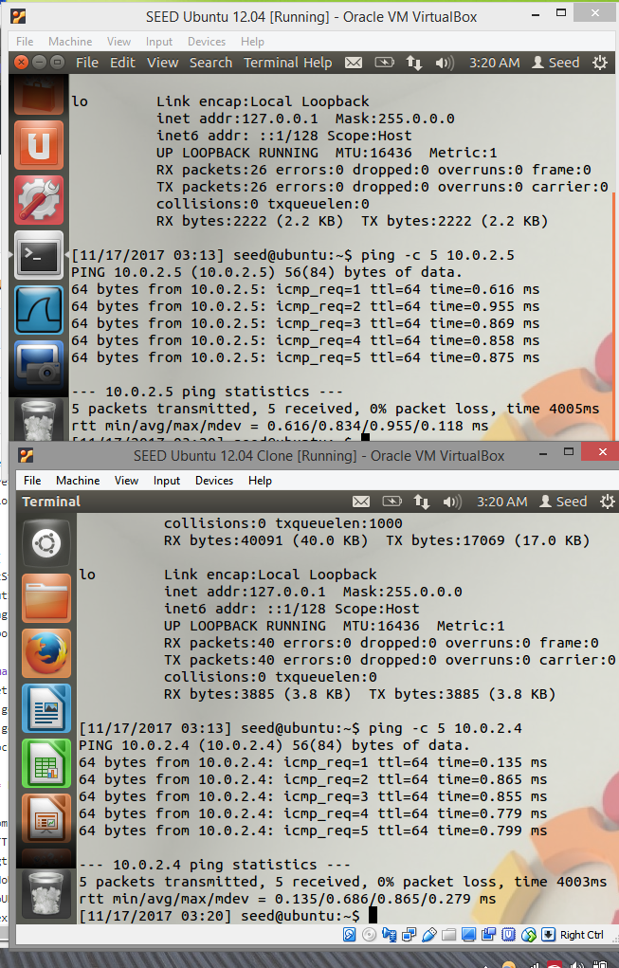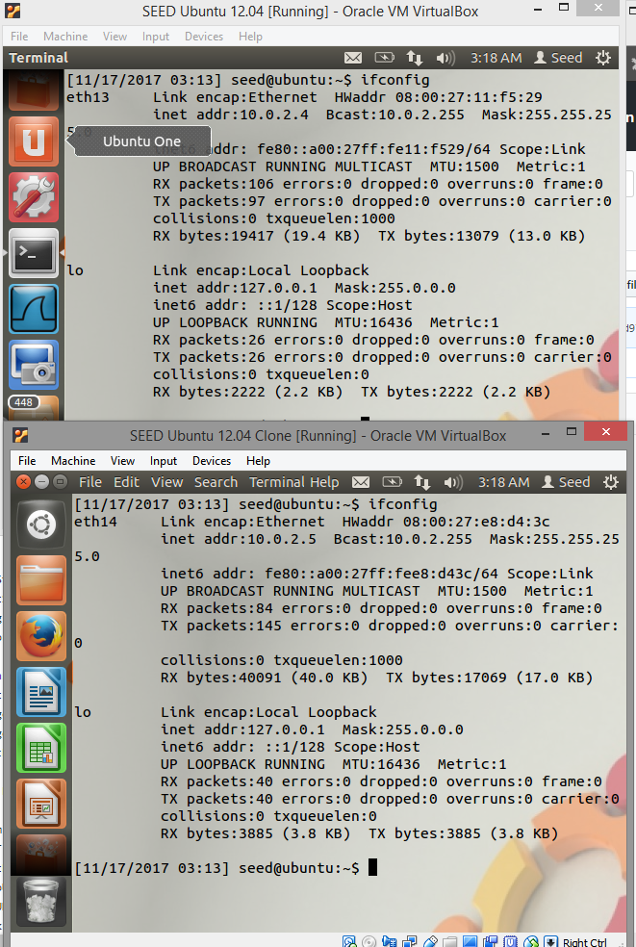

3.2

The sniffex script initially doesn’t start properly because the VM does not have permission to capture on that device aka socket: operation not permitted.

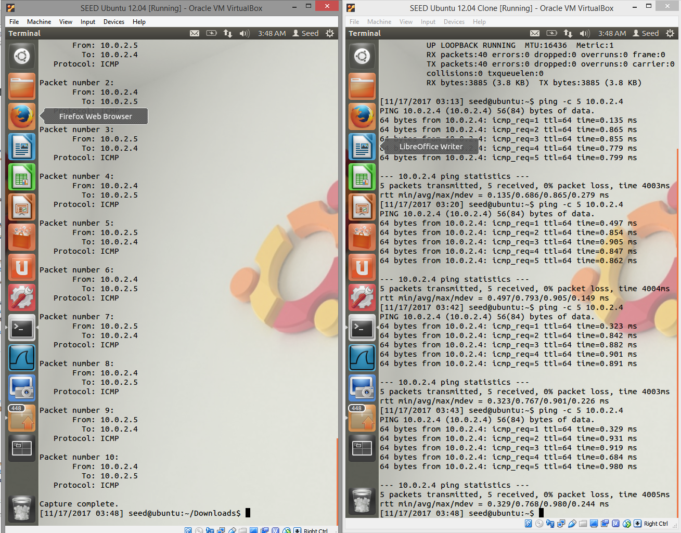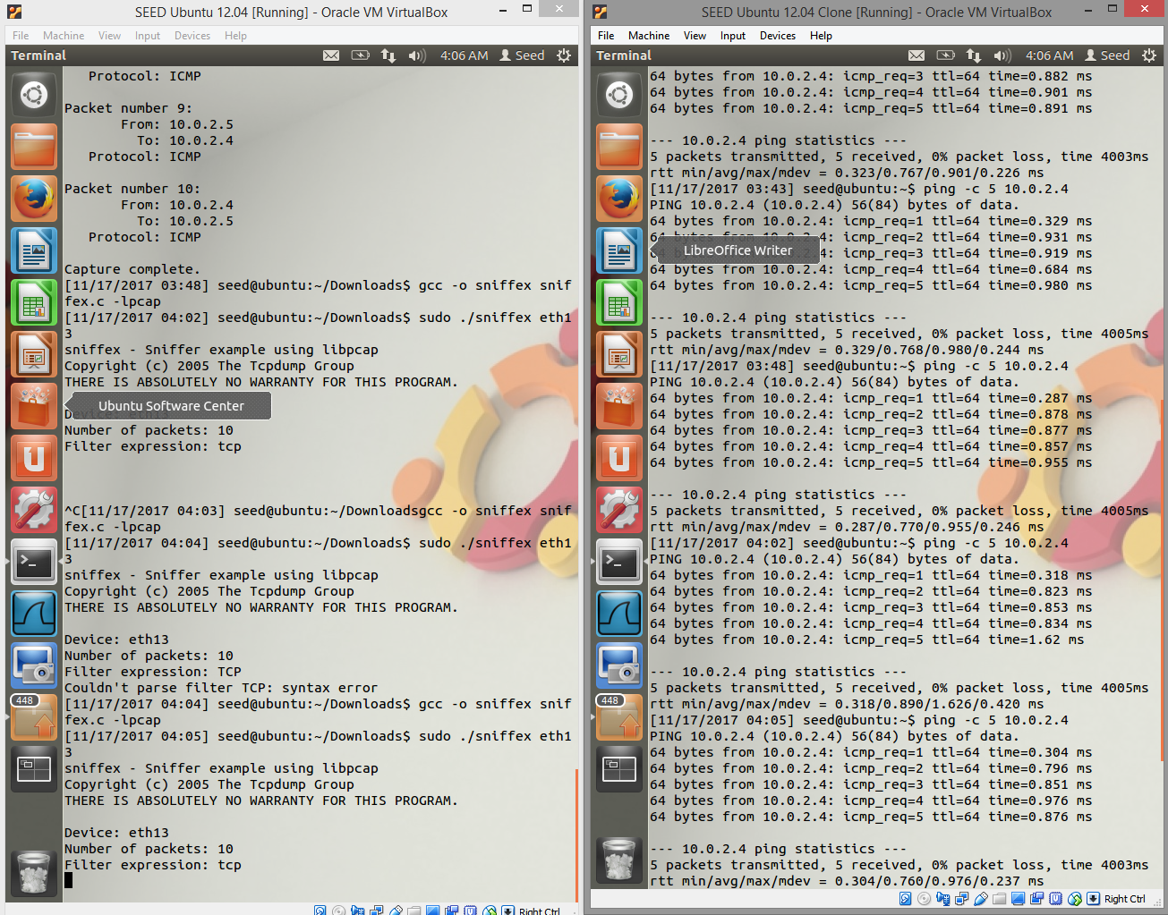

Filter expression was changed from “ip” to “tcp”. Also, the first VM did not seem to receive the packets even though the VM clone successfully transmitted the packets., or takes significantly longer to receive packets.

3.3

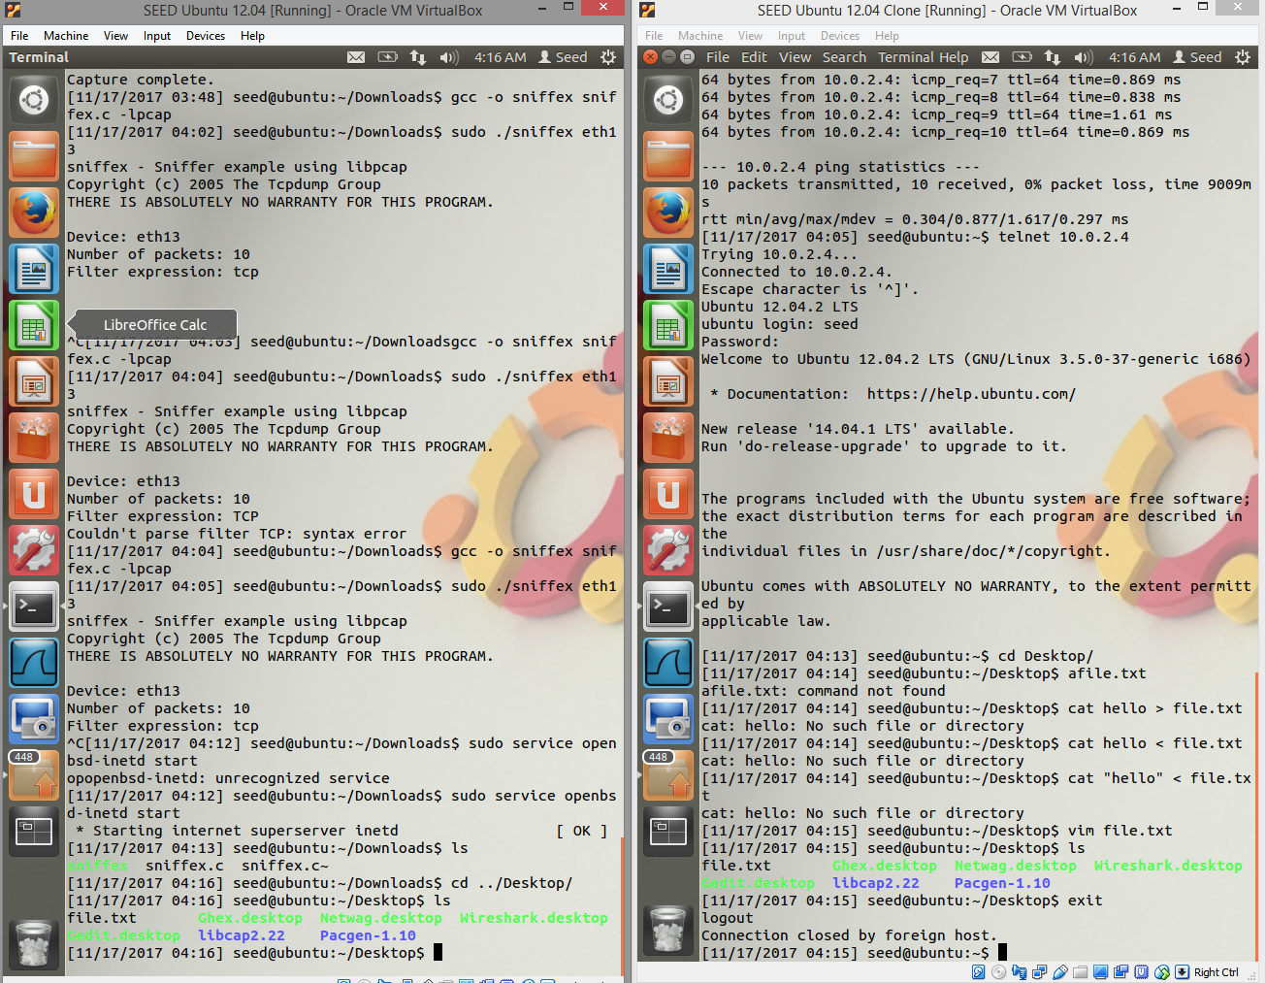

The telnet protocol is unsecure and can reveal private information unwillingly.

3.4

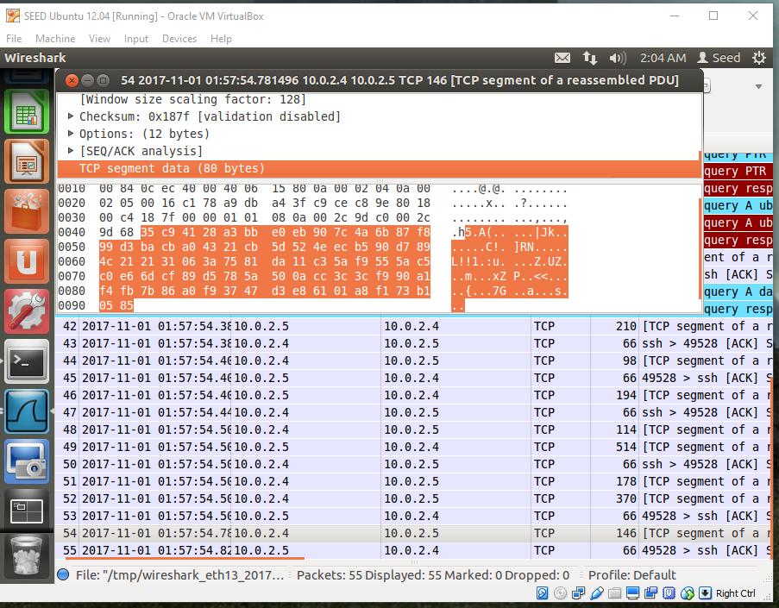

By using SSH with Wireshark, data is encrypted so we cannot read the user name and password.